**Assignment 1:**

1. **Create a jupyter notebook**: Click here [visualization1](https://refactored.ai/dsin100days/play/notebooks/cs/usr/dsin100days/content/02-Python_for_Data_Scientists/10-Data_Visualization_with_Matplotlib_and_Plotly/Lab-Data_Visualization1.ipynb) and follow instructions on the notebook thereafter.
2. Save jupyter notebook created as a pdf file under the name “visualization1”, following instructions on the screenshot below.

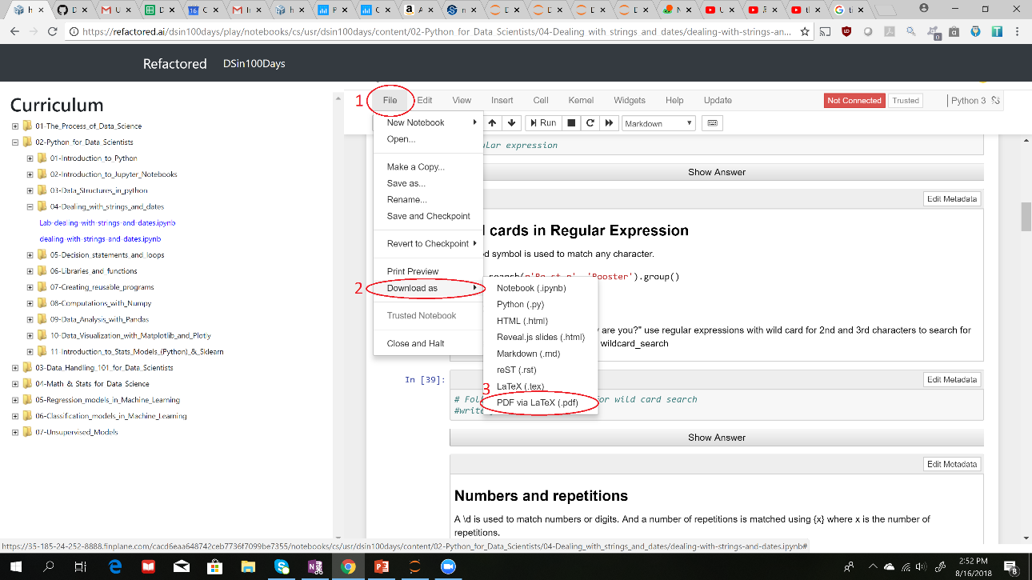

1. **Deliverables:** Submit your saved pdf (visualization1) file.

**Assignment 2:**

1. **Create a jupyter notebook**: Click here [visualization2](https://refactored.ai/dsin100days/play/notebooks/cs/usr/dsin100days/content/02-Python_for_Data_Scientists/10-Data_Visualization_with_Matplotlib_and_Plotly/Lab-Data_Visualization2.ipynb) and follow instructions on the notebook thereafter.
2. Save jupyter notebook created as a pdf file under the name “visualization2”, following instructions on the screenshot below.



1. **Deliverables:** Submit your saved pdf (visualization2) file.